Data Races

Course Level:

CS1/CS2

PDC Concepts Covered:

PDC Concept | Bloom Level
Data Races

Programming Knowledge Prerequisites:
Basic knowledge of computer memory

Tools Required:
Internet Connection
Edit access to supplied spreadsheets in a shared environment (such as a google drive).
Timer (optional)

Introduction:
The main goal of this module is to introduce the basic concept of a data race through a visual interaction. This is done by having each student fill an array of cells in a shared spreadsheet. The color of a cell is based on the last person who modified it.

Activity Description:

- Pair up students
- Copy Sheet 1 so that each pair of students has access to a copy. Figure 1.
- Let each student pick either the row or column and a color.
  - Alternately, assign a color for each row and column on a sheet.
- Each student begins in the indicated cell.
- When you signal, each student attempts to fill their row or column with their color cell by cell in the direction of the arrow.
  - Filling cell by cell helps demonstrate sequential memory writes, but if a student uses the drag functions to fill their area it is not an issue.
- The color of the overlapping cells will change depending on who fills them last (Example result in figure 3.)
  - You may repeat this giving one student a delay before starting.
- Split students into groups of up to 4 and follow steps 1 through 5 for sheet 2. Once again the overlapping cells color will depend on who modified it last. Figure 2.

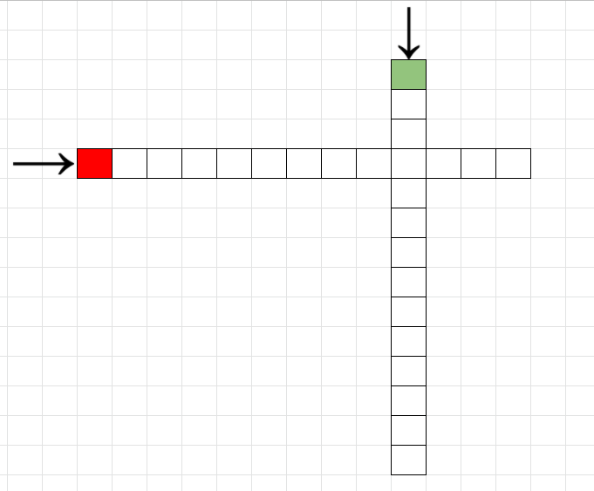Figure 1: Two Person Race

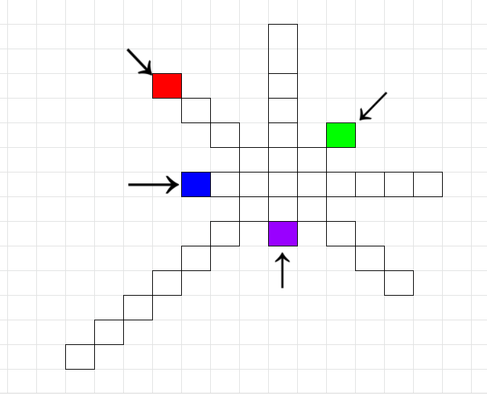Figure 2: Four Player Race
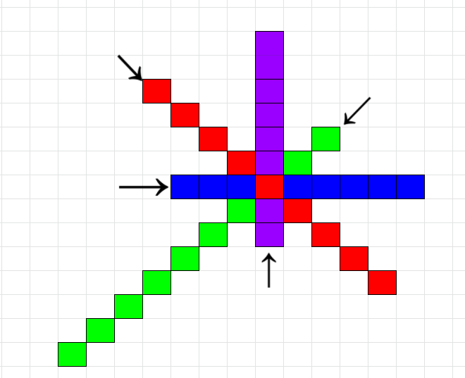
Figure 3: Possible Result:
The center square has been written to by all the students, but red wrote last so it appears red to everyone.

